**The Effect of Spending Per Pupil on Academic Achievement in Middle School**

By Emiliano Villarreal, The University of Texas at Austin

ev8559

**Abstract**

Increasing academic achievement is an important issue for the parents of America. Most parents are concerned with academic achievement and are interested in ways to increase the level of achievement of their children. Utilizing publicly available state-level data on average test scores per state, spending per pupil, and controlling for several variables such as income, poverty, and race will allow us to run a linear regression focusing on how spending per pupil affects academic achievement. The test revealed that as spending increases by one dollar, there will be a -0.0005873 decrease in middle school math test scores across states (p-value<0.01). According to the results, the government should look towards strategies other than increasing spending in order to improve academic achievement

**Introduction**

Education has always been an important issue in political discourse. From Head Start to No Child Left Behind, increasing the quality education has been a goal of many administrations. A way to measure the quality of education is by measuring academic achievement. The relevant literature has not yet settled on what methods are most effective to improve academic achievement. This is why this paper will address the following question, is increasing spending per pupil a method to increase academic achievement? This question is important because of the positive externalities brought upon by a more educated population. Positive externalities such as reduced crime (Fella 2014), increased health in a community (Arendt 2004), and as Nobel Laureate Milton Freidman said “A stable and democratic society is impossible without widespread acceptance of some common set of values and without a minimum degree of literacy and knowledge on the part of most citizens.”(Friedman 1955). Given these externalities, the government should aim to increase academic achievement.

The dependent variable is academic achievement of middle schoolers per state and the independent variable is spending per pupil by state. The measurement used for academic achievement used in this paper will be average math scores of 8th graders in the National Assessment for Educational Progress (NAEP 2019) in each state. As for spending per pupil, per pupil current spending will be used. Per pupil current spending is derived by the census and describes a state’s spending on public schools divided by the amount of pupils enrolled.

If increasing spending per pupil is found to have a significant positive effect on academic achievement, then the government ought to increase spending per pupil. Otherwise, the government will have to look at factors other than spending to increase academic achievement. This paper will check the impact of spending on academic achievement.

**Literature Review**

The relevant literature offers a wide variety of conclusions. Conclusions range from spending having a positive effect on academic achievement (Miller 2018), to only certain types of spending having a positive effect (Wenglinsky 1997), to spending having no effect on academic achievement (Lips 2008).

In his research, Lips (2008) uses data from the US Department of Education to derive average NAEP reading scores and National Center for Education Statistics data to track Per-Student Expenditures in American Public Schools from 1970–2005. From comparing the rise in expenditures and the flatness of average NAEP reading scores, Lips concludes that the ever increasing spending on education has not been conducive to a relative increase in academic achievement. He advocates for policies that improve resource allocation and reduce bureaucracy instead of increasing funding in order to increase academic achievement.

On the other hand, Wenglinsky (1997) gathered data from NAEP, CCD, and TCI to find information on student achievement and spending. Wenglinsky looked at per-pupil expenditures on instruction and central office administration, teacher-student ratios, teachers' education, school social environment, students' academic achievement, students' SES (socioeconomic status), academic achievement, per-pupil expenditures on administration at the school level and per-pupil capital outlays. Wenglinsky compared restricted and unrestricted models to conclude that if the money was used to increase the number of teachers and decrease the teacher-student ratio, increased spending was effective in increasing academic achievement. However, if the money was spent on increasing the administration, the money will reach a ‘dead end’ in terms of increasing academic achievement.

Another example of the range in conclusions in the relevant literature is Miller’s (2018) study. Miller uses Stanford Educational Data Archive (SEDA) for test scores and National Center for Education Statistics’ Common Core of Data (CCD) to find graduation rates as measures of education quality. He gathered data from each state and created his own database to derive property values. He uses data from CCD to gather expenditures, revenues, and the number of students in several race categories. Miller got median household income from the census and school finance data from the Department of Education. He then used the data he gathered to form a OLS estimator and found “A 10 percent increase in spending also increases 4th and 8th grade math and reading scores by between 0.05 and 0.09 standard deviations.”

**Empirical Model**

A linear regression is used to estimate the relationship between Current Spending per Pupil and Academic Achievement. In this study, Academic Achievement is the dependent variable and Current Spending per Pupil is the independent variable. In this paper we estimate the following regression model:

*Academic Achievement* = 𝛼 + *B*1 *Spending* + *B*2 I𝑛𝑐𝑜𝑚𝑒 + *B*3 *Poverty* + *B*4 *White + B*5 *Black + B*6 *Native American* + *B5* Indian + *B6* Hawaiian + *B*7 𝑅𝑒𝑔𝑖𝑜𝑛 + 𝑢

In the model above, Academic Achievement measures average 8th grade NAEP math scores per state. Spending variable is made up of Current Spending per Pupil. Current Spending is the division of “payments for salaries, employee benefits (including local school system employer contributions to state government retirement funds),payments made by the state government on behalf of school systems, and transfers made by school systems into their own retirement funds”(Census 2021) by number of pupils in public elementary-secondary school in the respective state. Poverty variable represents the poverty rate of each state. Income variable captures median income. Race variable is accounted for by omitting Asian as a control variable. Finally, we control for geographic region; South is excluded.

**Data**

This paper uses publicly available state-level data. Academic achievement is based on the [2019 Nation’s Report Card](https://www.nationsreportcard.gov/profiles/stateprofile?chort=2&sub=MAT&sj=AL&sfj=NP&st=MN&year=2019R3). The data reflects average math scores of 8th graders in the National Assessment for Educational Progress (NAEP 2019).

Data regarding spending was gathered from the US Census’ [Annual Survey of School System Finances](https://www.nationsreportcard.gov/profiles/stateprofile?chort=2&sub=MAT&sj=AL&sfj=NP&st=MN&year=2019R3). The metric used from the survey is Current Spending per Pupil as defined in the empirical model section.

Data regarding race is from the US Census’ [2019 ACS 5 year estimates](https://data.census.gov/cedsci/table?g=0100000US%240400000&tid=ACSDT5Y2019.B03002&hidePreview=true).A variable is created for each race but Hispanic which will be the control variable.

State characteristics include poverty rate (percent of the population at or below poverty), and annual median income. All state characteristics were obtained for 2019 from the Kaiser Family Foundation. Income variables used in this study can be found at [State Category | Household Income | KFF](https://www.kff.org/state-category/demographics-and-the-economy/household-income/).

Table 1 below presents descriptive statistics

Table 1. Descriptive statistics

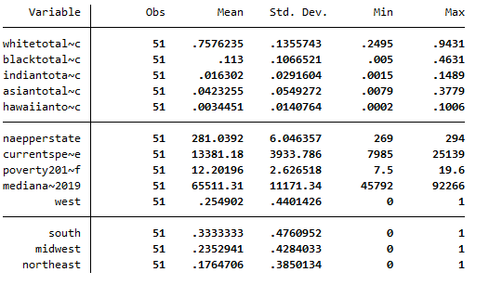

Table 1 above shows a small standard deviation of 6.05 in NAEP scores. NAEP math scores varied from a 269 score in the District of Columbia to 294 score in Massachusetts with an average score of 281.04. Current Spending per Pupil has a standard deviation of 3,933 dollars. Current Spending per Pupil ranged from 7,985 dollars in Idaho to 25,139 dollars in New York with a mean of 13,381.18 dollars. Poverty showed a standard deviation of 2.627 percent. Poverty ranged from 7.5 percent of the population in New Hampshire to 19.6 percent in Mississippi with a mean of 12.202. Median income has a standard deviation of 11,171.34 dollars. Median income ranges from 45,792 dollars in Mississippi to 92,226 dollars in the District of Columbia. Percentage of white people ranged from 24.95 % in Hawaii to 94.31 % in Maine.

**Empirical Results**

Regression results in Table 2 below show that Current Spending per Pupil has a significant effect on the academic achievement of middle schoolers (P<0.05). The coefficient of Current Spending per Pupil indicated a negative effect of -0.0005873 per dollar spent on academic achievement.

Table 2. Regression Results

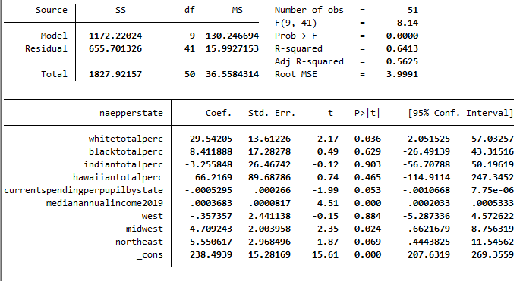

Midwest, Northeast, and percentage of White people were also found to have a sizable effect on academic achievement. Percentage of White people was found to have a positive effect on academic achievement (p<0.05). If the percentage of White people increases by 1%, NAEP math scores increase by 0.2954 points in the state.The Midwest region was found to have a positive effect on academic achievement (p<0.05). If a state is found to be in the Midwest, the average NAEP math score will increase by 4.709 points. The Northeast region was found to have a positive effect on academic achievement (p<0.1). If a state is found to be in the Northeast, the average NAEP math score will increase by 5.55 points. All other variables were statistically insignificant with p-values > 0.1

**Further Tests**

Throughout this study we have had multiple assumptions of errors within residuals that we now must test for to reinforce our results. These assumptions are no heteroskedasticity, normal residuals, no multicollinearity, and omitted variables. Proving these assumptions is important because they are necessary for valid hypothesis testing. Specifically, normality in residuals ensure that our t-tests, f-tests, and p-values are reasonable and justifiable. To test for the normality assumption, the Skewness-Kurtosis All Normality Test is used.

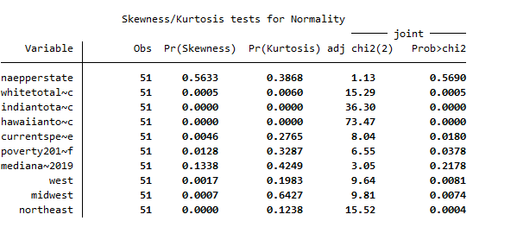

By analysing the dependent variable, naepperstate, we see that its p-value is greater than .05 (.56) and passes the normality test.

**Variance Inflation Factor Test**

The next will test for multicollinearity in the model which happens when a perfect linear relationship between two variables is present. If multicollinearity is found, coefficients and standard errors would be unstable and inflated.

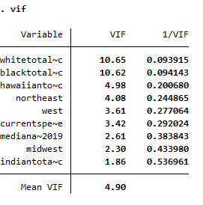

Since the mean VIF is < 10 there's no significant multicollinearity in the variables. The model passes the VIF test.

**Breusch-Pagan Test**

To test for heteroskedasticity, which means the residuals have unequal spread, we will use Breusch-Pagan Test

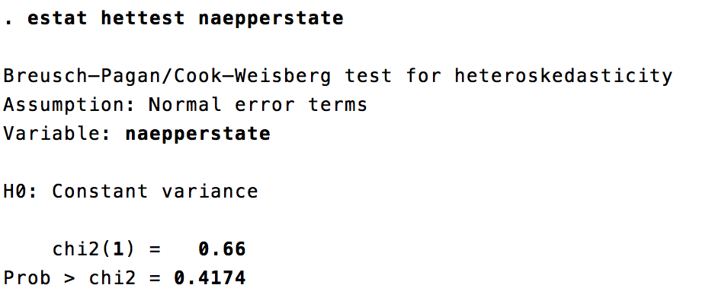

In this test, the p-value is greater than 0.05 (0.4174). Therefore we fail to reject the null (constant variance a.k.a homoscedasticity) and there is likely no heteroskedasticity in the residuals.

**Ramsey Test**

The final test, the Ramsey test, analyzes whether or not non-linear combinations of the fitted values help explain the dependent variable. If they do, that means the model could be incorrectly specified.

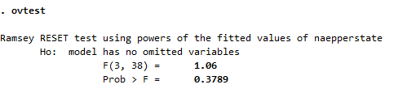

At this p-value (0.3789), we fail to reject the Ho so the model likely has no variables being omitted and is adequate according to the test.

**Conclusions and Policy Implications**

Empirical results show that Current Spending per Pupil is a significant factor in middle schooler’s academic achievement (p<0.05). These findings go along with the results found in Lips (2008). According to the regression results, the government should look to strategies other than increasing spending per pupil to increase academic achievement. Strategies such as reducing the number of administrators to hire more teachers and reducing the pupil-teacher ratio might help increase academic achievement.

The results of this study have their own limitations. This study uses a narrow definition of academic achievement. The measure for academic achievement in middle schoolers used in this paper only looks at the math NAEP math scores of 8th graders, leaving out other grades and subjects.

**References**

1. “NAEP State Profiles.” *The Nation's Report Card*, <https://www.nationsreportcard.gov/profiles/stateprofile?chort=1&sub=MAT&sj=&sfj=NP&st=MN&year=2019R3>.
2. Giulio Fella, Giovanni Gallipoli, Education and Crime over the Life Cycle, *The Review of Economic Studies*, Volume 81, Issue 4, October 2014, Pages 1484–1517, <https://doi.org/10.1093/restud/rdu014>
3. Arendt, Jacob Nielsen. “Does Education Cause Better Health? A Panel Data Analysis Using School Reforms for Identification.” *Economics of Education Review*, Pergamon, 23 July 2004, https://www.sciencedirect.com/science/article/pii/S0272775704000688.
4. Friedman, Milton. *The Role of Government in Education - the University of ...* 1955, https://la.utexas.edu/users/hcleaver/330T/350kPEEFriedmanRoleOfGovttable.pdf.
5. Bureau, US Census. “Annual Survey of School System Finances Technical Documentation.” *Census.gov*, 8 Oct. 2021, https://www.census.gov/programs-surveys/school-finances/technical-documentation/complete.html.
6. Bureau, US Census. “Public School Spending per Pupil Increases.” *The United States Census Bureau*, 18 May 2021, https://www.census.gov/newsroom/press-releases/2021/public-school-spending-per-pupil.html.
7. Lips, Dan|Watkins. “Does Spending More on Education Improve Academic Achievement? Backgrounder. No. 2179.” *Heritage Foundation*, Heritage Foundation. 214 Massachusetts Avenue NE, Washington, DC 20002-4999. Tel: 202-546-4400; Fax: 202-546-8328; e-Mail: Info@Heritage.org; Web Site: Http://Www.heritage.org, 8 Sept. 2008, https://eric.ed.gov/?id=ED509499.
8. Wenglinsky, Harold. “How Money Matters: The Effect of School District Spending on Academic Achievement.” *Sociology of Education*, vol. 70, no. 3, [Sage Publications, Inc., American Sociological Association], 1997, pp. 221–37,<https://doi.org/10.2307/2673210>.
9. Miller, Corbin L. “The Effect of Education Spending on Student Achievement: Evidence from Property Values and School Finance Rules.” *Proceedings. Annual Conference on Taxation and Minutes of the Annual Meeting of the National Tax Association*, vol. 111, National Tax Association, 2018, pp. 1–121, https://www.jstor.org/stable/26939356.